Name: Nan Xu
Class: Business requirements gathering and design
Date: 2024/03

Use Case for System Enhancement

Name: Automate Order and Billing Process
Actors:
Designer
Accounting Clerk
System (Automated order entry and billing system)
Designer: Initiates the order process.
Accounting Clerk: Manages billing, payment processing, and late notices.
System: Automated order entry and billing system.

Description:
This use case outlines the automated process for order entry and billing, designed to increase efficiency in invoice preparation, payment processing, and late notice dispatch. It ensures that as customer demand grows, Creative Designs can maintain timely and accurate billing and payment recording.

Pre-Condition:
The designer has completed the order details with the customer.
The system is accessible and operational for the designer and accounting clerk.

Post-Condition:
The customer's order is automatically entered into the accounting software.
Invoices are prepared and sent out promptly at the end of the billing cycle.
Payments are recorded daily, reducing the backlog and inaccuracies in billing and payment recording.
Late notices are automatically generated and sent only to customers with overdue payments.

- Workflow Diagram
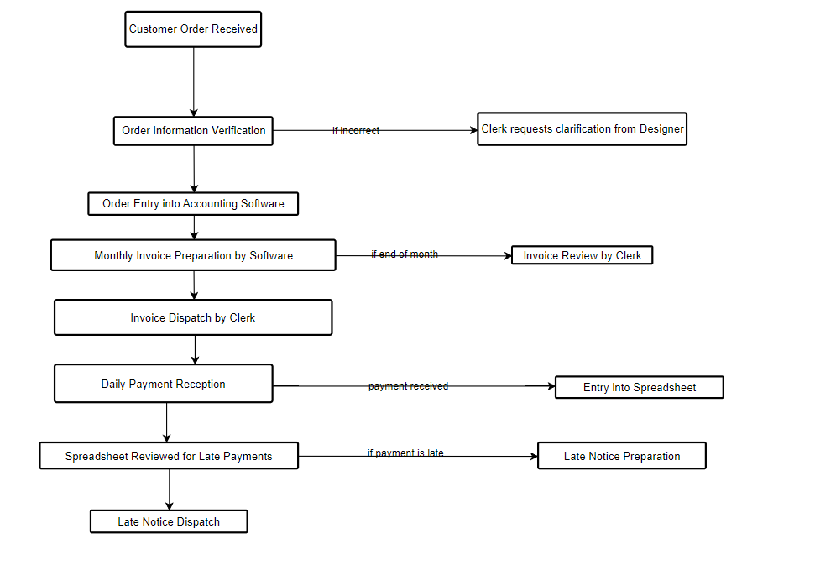

3. Data Flow Diagram (DFD), Level 0 Context
